**Project 100011:** [Map your mind](https://intranet.alxswe.com/projects/100011)

Presented by **Yassir BOUKHIMA**

________________________

**FLOW CHART**

**FUNCTION:** calculate the sum of squares of the given input of numbers

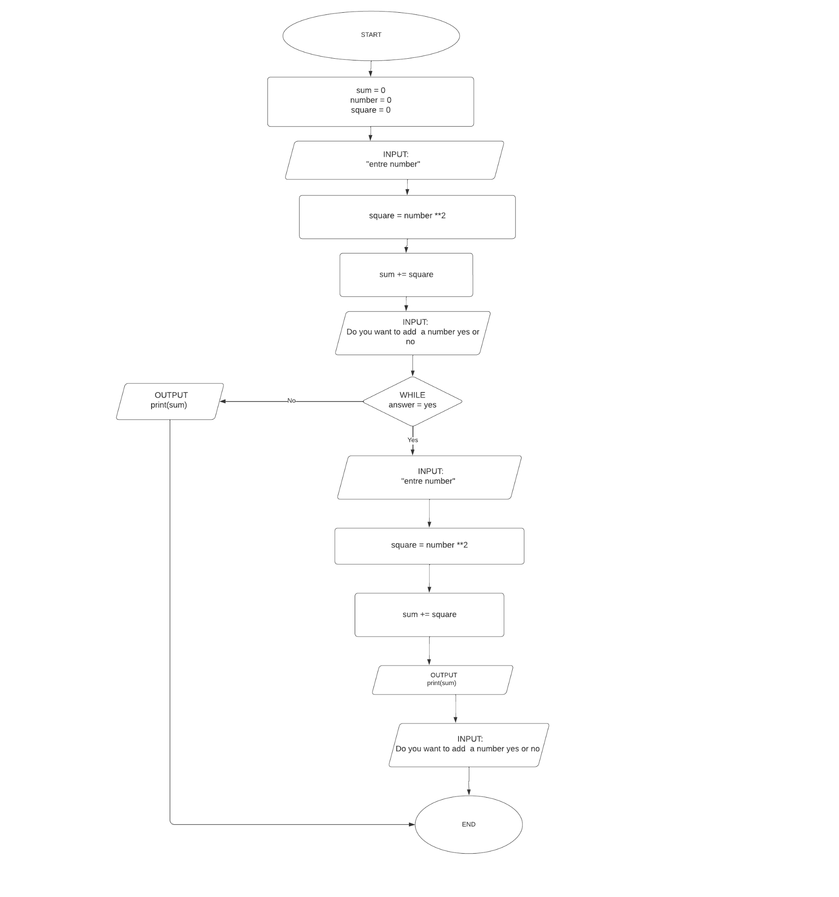

**pseudocode**

* START
* sum = 0
* number = 0
* square = 0
* INPUT: "entre number"
* square = number **2
* sum += square
* INPUT: Do you want to add a number yes or no
* WHILE answer == “yes” :
  + INPUT: "entre number"
  + square = number **2
  + sum += square
  + OUTPUT print(sum)
  + INPUT: Do you want to add a number yes or no
* OUTPUT print(sum)
* END

python code (option)

sum=0

number = 0

square=0

number=int(input("entre number:"))

square = number**2

sum += square

answer = str(input(" Do you want to add a number yes or no:))

while (answer == "yes"):

number=int(input("entre number:"))

square = number**2

sum += square

print({sum})

answer = input(" Do you want to add a number yes or no")

print({sum})